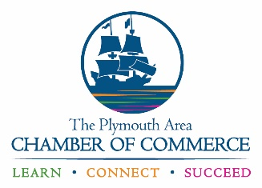
Plymouth Area Chamber of Commerce
100 Armstrong Road, Suite 204
Plymouth, MA 02360
Phone: (508)-830-1620
www.plymouthchamber.com

Assumption of Risk & Waiver of Liability Relating to Coronavirus/COVID-19
The novel coronavirus, COVID-19, has been declared a worldwide pandemic by the World Health Organization. COVID-19 is extremely contagious and is believed to spread mainly from person-to-person contact. As a result, federal, state, and local governments and federal and state health agencies recommend physical distancing and have, in many locations, prohibited the congregation of groups and people.
The Plymouth Area Chamber of Commerce has put in place preventative measures to reduce the spread of COVID-19; however, the Chamber cannot guarantee that you, or any other person, will not become infected with COVID-19. Further, attending and participating in The Waterfront Pop-Up could increase your risk of contracting COVID-19.
By signing this agreement, I acknowledge the contagious nature of COVID-19 and voluntarily assume the risk that I may be exposed to or infected by COVID-19 by attending and participating in The Waterfront Pop-Up and that such exposure or infection may result in personal injury, illness, permanent disability, or death. I understand that the risk of becoming exposed to or infected by COVID-19 at The Waterfront Pop-Up activities may result from the actions, omissions, or negligence of myself and others, including but not limited to Plymouth Area Chamber of Commerce employees, volunteers, and program participants.
I voluntarily agree to assume all of the foregoing risks and accept sole responsibility for any injury to myself, including, but not limited to, personal injury, disability, death, illness, damage, loss, claim, liability, or expense or any kind, that I may experience or incur attending and participating in The Waterfront Pop-Up. On behalf of myself, I hereby release, covenant not to sue, discharge, and hold harmless and indemnify the Plymouth Area Chamber of Commerce, its employees, agents, and representatives, of and from any and all claims, including all liabilities, claims, actions, damages, costs or expenses of any kind arising out of or relating thereto. I understand and agree that this release includes any claims based on the actions, omissions, or negligence of the Plymouth Area Chamber of Commerce, its employees, agents and representatives, whether a COVID-19 infection occurs before, during, or after participation in The Waterfront Pop-Up.

____________________________________________________________________________
Signature of Exhibitor Date

_____________________________________________________________________________
Print Name of Exhibitor

